PROJECT INOVATION
TUTORIAL ON ICT TOOL ‘FRITZING’
We the students team from dldav model school pitampura india have made a tutorial to FRITZING in which we have shown how to use a software called FRITZING.Basically FRITZING is used to make virtual circuit or circuit diagram .We have also used a software called Plotagon to create a animation which will create our presentation more interesting and attractable . We are making a basic project led flasher or led chaser in which we have used 4 led , 5 transistors (BC547) , one capacitor , one condenser mic , a lot of resistors and a 9v battery . We have used a breadboard to assemble these parts. We arrange the parts according to the circuit diagram as shown
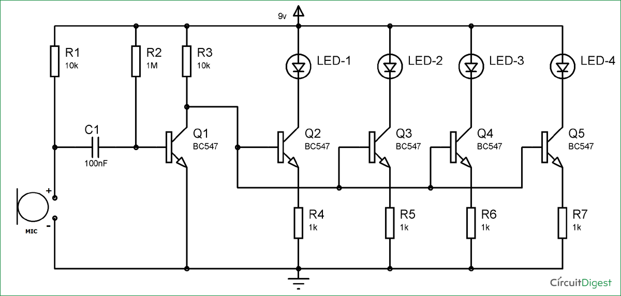
We have to first arrange transistors on breadboard according to the circuit diagram . Then we will join transistors first leg to the led negative leg and the second (middle) leg of the transistor to each other which are then connected to first transistors first leg. Then we will connect a capacitor first leg to the middle leg of the first transistors middle leg and the other leg of the capacitor to the positive leg of the condenser microphone, Then we will connect the resistors according to the circuit diagram i.e. one leg of resistor to the last leg of the transistors and the second leg of the resistor to each other which are then connected to a ground connection . Then we will connect a resistor to the first leg of the transistor (from which we have connected all transistors middle leg) which is then connected to the positive leg of the led which is also connected to the positive of the 9v battery. Then we will connect a resistor to the middle leg of the transistor (from which capacitor is connected) and the second leg of the resistor to the positive of the led . We will connect the negative leg if the condenser microphone to the transistors third leg or from where all the resistance are connected which is then connected to the ground . We can also add a switch where the condenser microphone and transistors third leg is connected to operate the circuit.

Made by
Students from DLDAV Model School Pitampura
Delhi INDIA

